1. January had the most stops, with 1482. This was followed by May with 1357 and February with 1329. Full list is contained in Q1A.  
   ‘Fits a relevant description’ was the most common reason, for 5870 cases. This was followed by ‘Other’ for 5378 cases and ‘Furtive movements’ for 2234 cases. Full results are contained in Q1B.
2. If one were to define success simply through rate of finding contraband given that a search is undertaken, the following would be the most successful districts -   
     
   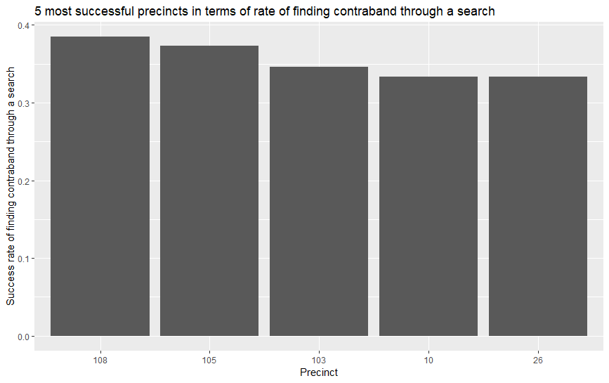  
   It is to be noted that this metric will be very skewed for precincts with low instances of searches. A single successful or unsuccessful search would greatly impact this metric. Hence, if this metric is modified such that only precincts with at least 75 searches are chosen (75 corresponded to roughly the bottom 10th percentile of search frequency), the following precincts are identified as most successful –

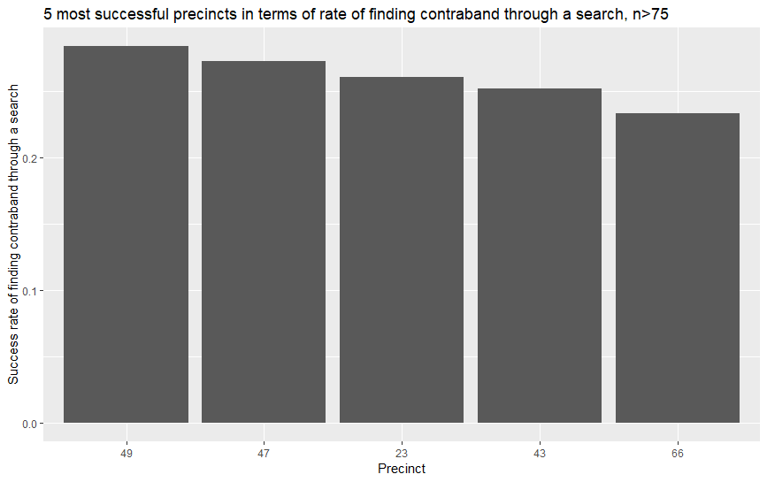

1. On average, 1.52916 is the average number of reasons for which a suspect is frisked. There is a heavy skew in the distribution of number of reasons why a suspect is frisked. Analysis found in code.

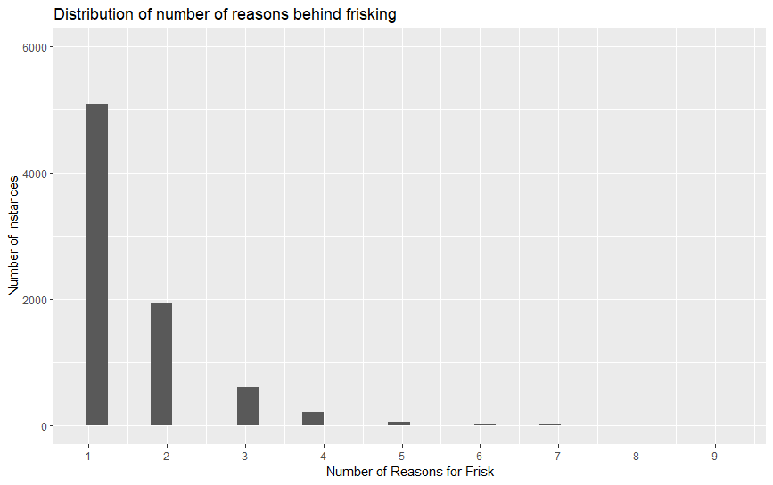

1. First, an arrest rate is calculated that shows ratio of arrests to total searches per precinct. Assuming that, an arrest rate of 0.35 is considered ‘high-risk’, the following are outliers per precinct –

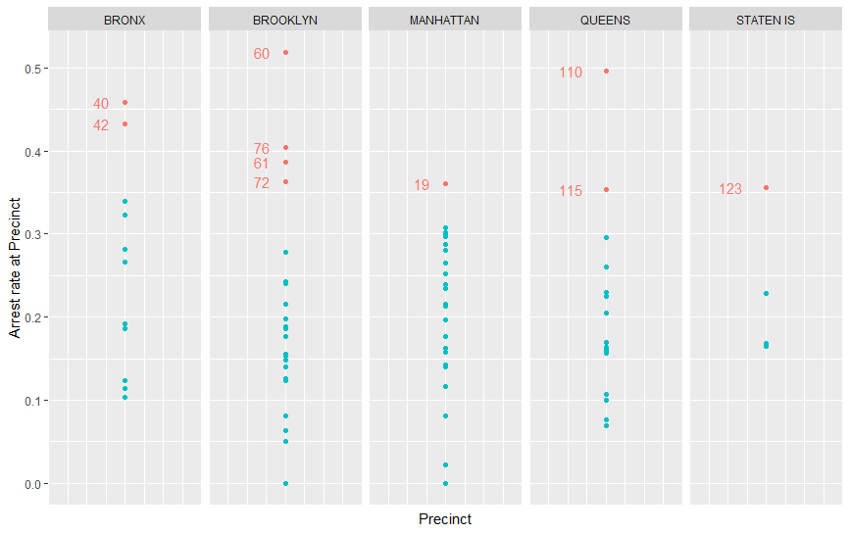

A heat map with ggmaps would work very well too. Unfortunately I’m not skilled enough to do that yet.

1. Based on the previous image, 40, 42, 110 and 60 seem dangerous. In addition, every district has more than 185 cases, meaning that these aren’t figures distorted by low case frequency. If we analyse total number of cases for individual cases, there are curious patterns for each district. 40 is particularly high-traffic for drugs, 110 for violent crime, 42 for other suspicion of weapons and 60 or casing. Hence, officers could be asked if these cases were particularly to be looked into per precinct.

One additional finding is that for both frisks and arrests, ‘other’ or ‘miscellaneous’ is always one of the most frequent reasons. This is despite the wide variety of possible scenarios for frisking or stopping. This could mean either of 2 things. Either, a cop’s job is extremely nuanced and that he/she faces a great variety of cases to deal with everyday. Otherwise, reporting for these statistics may be simply lazy. This would be dangerous as it would lead to inaccurate statistics, leading to loss of valuable information.